4 Ways to make your house guests feel Welcome & Wanted!
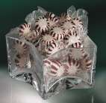Regardless of the season or the reason, having visitors in your home can be a lot easier on you if you organize and prepare in advance. A little planning provides an opportunity for you to find time to make people feel welcome. It ensures that their time spent with you is memorable. Listed here are some ideas to help you welcome your guests with warmth, hospitality and ease: (1) allow your guests some privacy, (2) reserve some privacy for yourself, (3), plan one meal together a day, (4) arrange one group activity a day, (5) prepare the guest room(s) with a few extra touches 

 |  |  |  | Fine hotels leave mints on the pillow…you can leave a small bowl of mints on the bedside table.
Two magazines tied with a ribbon and laid on the bed is a great way to make your guests feel pampered.
 | 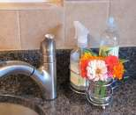 |  |  | A small flower bouquet for the guest bath countertop offers beauty at a minimal cost.
Make making lunch or an afternoon snack easy for your house guests. Create a spot in the pantry AND fridge for snack and lunch supplies so your guests can help themselves.  Efficiency = free time for you! |  |  |  |  |  | 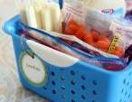
© 2016, Vicki Winterton is a Utah based home organizing professional and owner of Organizing Mind over Matter.
She teaches homeowners and work-at-home businesses how to reclaim their time and space. Vicki can be reached at vicki@organizeutah.com Visit her website for additional organizing tips at www.organizeutah.com

