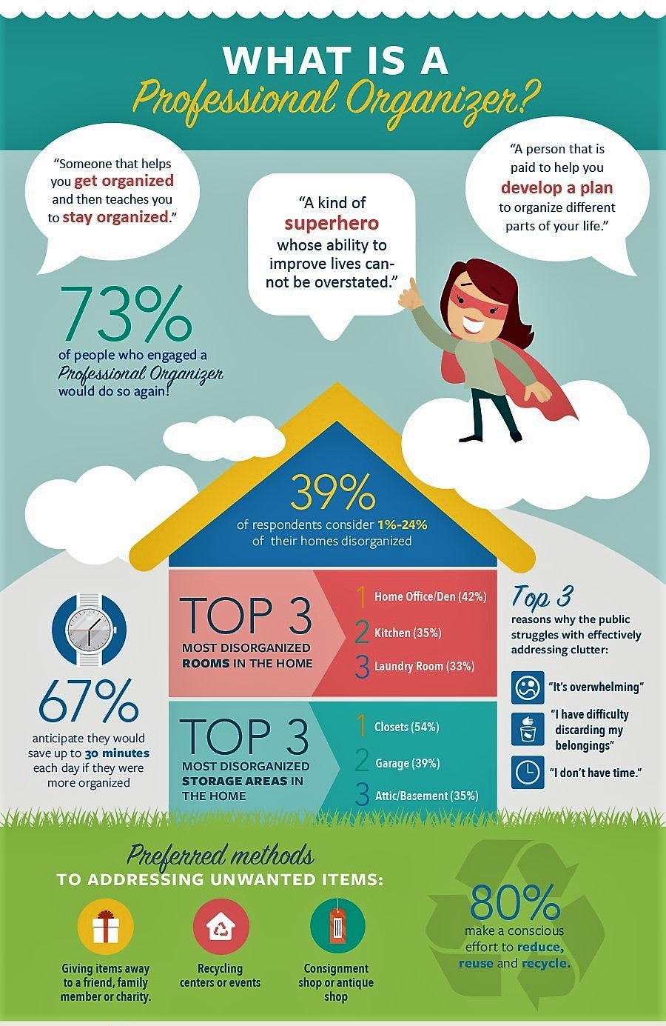
This info was uncovered by way of a major public opinion survey done in 2017 by the National Association of Professional Organizers.

